ECE 278C – Imaging Systems

Assignment 1: Fourier Spectrum of Coherent Wavefield

Name: Xinyi Yang
Date: October 13, 2025

$$Part A$$
- Single Point Source
$$H(f_{x},f_{y})=\iint{h(x,y)}e^{−j2π(f_{x}x+f_{y}y)}dxdy$$
Wavefield Distribution
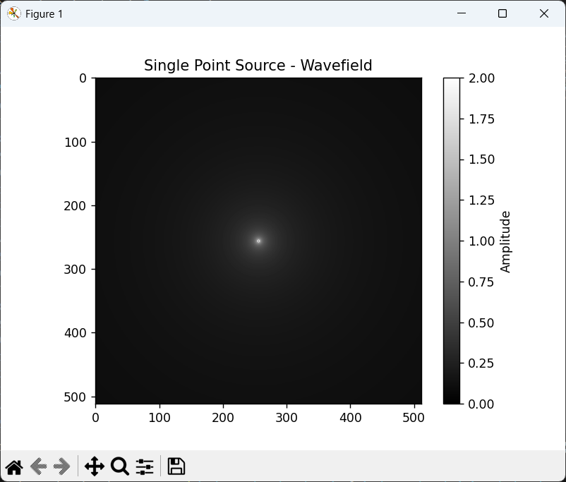
Fourier Spectrum
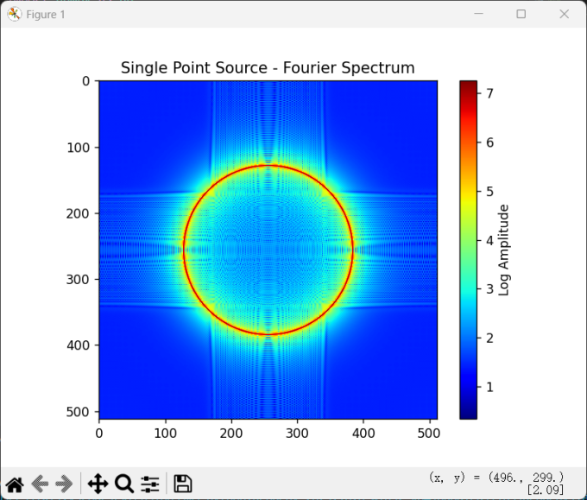
- Three Sources(Same $λ_{0}$)
$$h(x,y)=h_{1}(x,y)+h_{2}(x,y)+h_{3}(x,y)$$
$$H(f_{x},f_{y})=H_{1}(f_{x},f_{y})+H_{2}(f_{x},f_{y})+H_{3}(f_{x},f_{y})$$
Wavefield Distribution
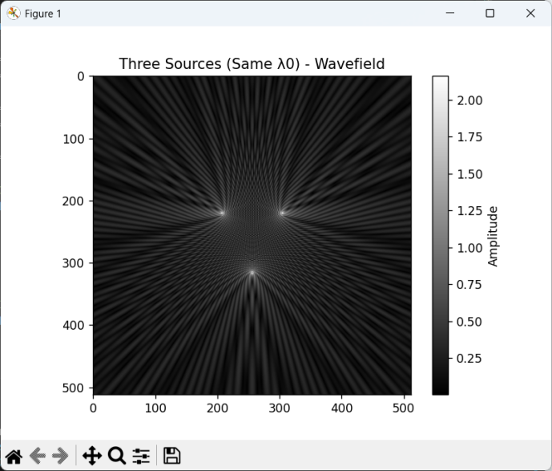
Fourier Spectrum
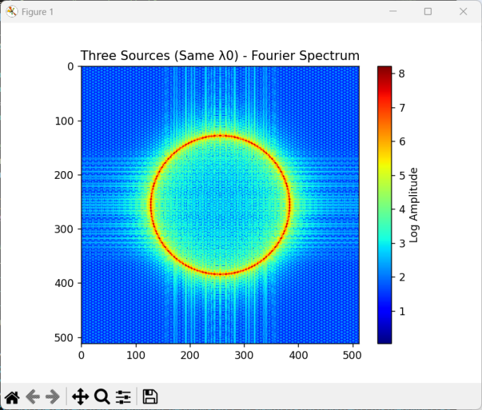
- Three Sources(Different $λ_{0}$)
Wavefield Distribution
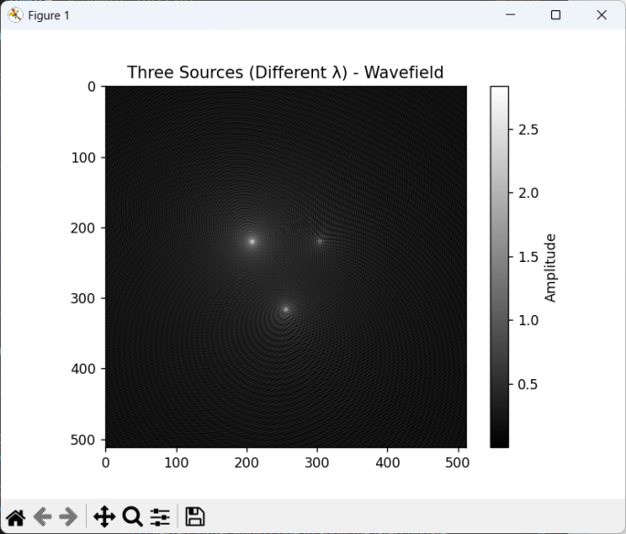
Fourier Spectrum
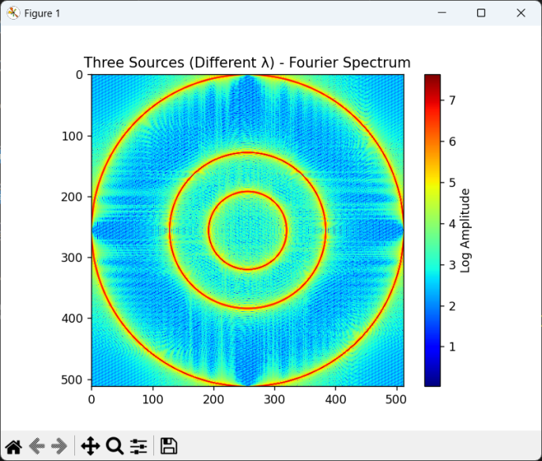

Part B:Phase-only Technique
$$h_{phase}(x,y)=e^{j∗arg(h(x,y))}$$
Wavefield Distribution
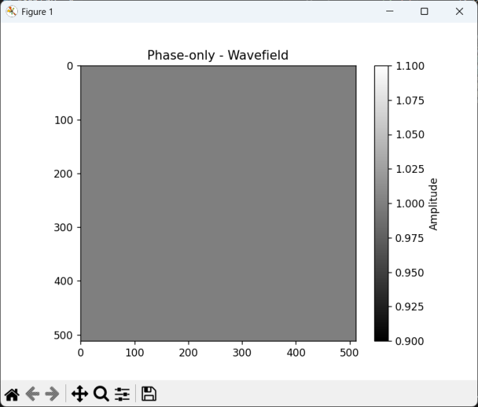
Fourier Spectrum
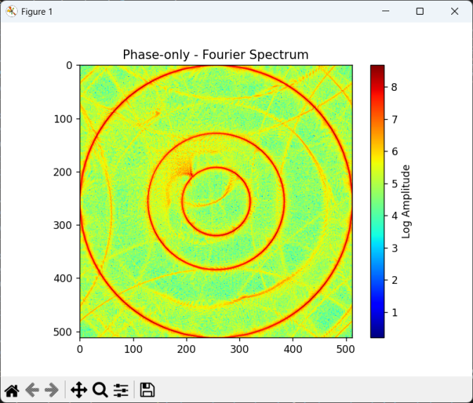

Summary
Through simulation of different coherent wavefield configurations, we observe that the Fourier spectrum strongly depends on source positions and wavelengths. A single point source leads to a circular spectrum, while multiple sources produce interference patterns. When sources of different wavelengths are used, the spectrum becomes richer and more complex. Finally, the phase-only technique confirms that phase is the dominant factor in preserving interference information, which has implications in phase retrieval and holography.

Appendix
Code
import numpy as np
import matplotlib.pyplot as plt

lam0 = 1.0 # wavelength λ0
dx = dy = lam0/4 # sample interval
N = 512 # FFT
L = 30*lam0 # aperture radius

x = np.arange(-N//2, N//2) * dx
y = np.arange(-N//2, N//2) * dy
X, Y = np.meshgrid(x, y)
R = np.sqrt(X**2 + Y**2)

# Generate point source wave field
def wavefield(x0, y0, lam):
Rn = np.sqrt((X-x0)**2 + (Y-y0)**2)
h = np.exp(1j * 2 * np.pi * Rn / lam) / np.sqrt(1j * lam * Rn + 1e-9)
h[Rn == 0] = 0
return h

# Draw Wave field
def plot_field(field, title):
plt.figure()
plt.imshow(np.abs(field), cmap='gray')
plt.title(title)
plt.colorbar(label="Amplitude")
plt.show()

# Draw Spectrum
def plot_fft(field, title):
spectrum = np.fft.fftshift(np.fft.fft2(field, (N, N)))
magnitude = np.abs(spectrum)
plt.figure()
plt.imshow(np.log1p(magnitude), cmap='jet')
plt.title(title)
plt.colorbar(label="Log Amplitude")
plt.show()

# Part A (1) Single Point
h1 = wavefield(0, 0, lam0)
plot_field(h1, "Single Point Source - Wavefield")
plot_fft(h1, "Single Point Source - Fourier Spectrum")

# Part A (2) Three Sources(Same lam0)
h2 = (wavefield(0, 15*lam0, lam0) +
wavefield(-12*lam0, -9*lam0, lam0) +
wavefield(12*lam0, -9*lam0, lam0))
plot_field(h2, "Three Sources (Same λ0) - Wavefield")
plot_fft(h2, "Three Sources (Same λ0) - Fourier Spectrum")

# Part A (3) Three Sources(Different lam0)
h3 = (wavefield(0, 15*lam0, lam0) +
wavefield(-12*lam0, -9*lam0, lam0/2) +
wavefield(12*lam0, -9*lam0, 2*lam0))
plot_field(h3, "Three Sources (Different λ) - Wavefield")
plot_fft(h3, "Three Sources (Different λ) - Fourier Spectrum")

# Part B (4) Phase-only
phase_only = np.exp(1j * np.angle(h3))
plot_field(phase_only, "Phase-only - Wavefield")
plot_fft(phase_only, "Phase-only - Fourier Spectrum")

